Solution Workshop 8

|  |  |  |  |  |  |  |  |  |  |  |
| --- | --- | --- | --- | --- | --- | --- | --- | --- | --- | --- |
| **Workshop 8** | **Answers** |  |  |  |  |  |  |  |  |  |
| **1** | **1** | **0.29698123** | **0.26403933** | **0.206475143** | **0.23913658** | **0.27294405** | **0.09978267** | **0.03760148** | **0.24861254** | **0.18449117** |
|  | **0.296981235** | **1** | **0.2335995** | **0.235006499** | **0.2354852** | **0.30894693** | **0.13600548** | **0.04071235** | **0.28006169** | **0.25001259** |
|  | **0.264039332** | **0.2335995** | **1** | **0.181978189** | **0.19372481** | **0.22818011** | **0.15195751** | **0.00271851** | **0.28117771** | **0.25688747** |
|  | **0.206475143** | **0.2350065** | **0.18197819** | **1** | **0.26927979** | **0.31345519** | **0.13854585** | **0.03496491** | **0.23727108** | **0.16636506** |
|  | **0.239136583** | **0.2354852** | **0.19372481** | **0.269279786** | **1** | **0.47957966** | **0.10630992** | **0.03411353** | **0.23138821** | **0.18781607** |
|  | **0.272944051** | **0.30894693** | **0.22818011** | **0.313455194** | **0.47957966** | **1** | **0.12122504** | **0.06022246** | **0.30293534** | **0.2148768** |
|  | **0.099782667** | **0.13600548** | **0.15195751** | **0.138545848** | **0.10630992** | **0.12122504** | **1** | **0.04415339** | **0.20164825** | **0.09815455** |
|  | **0.037601484** | **0.04071235** | **0.00271851** | **0.034964906** | **0.03411353** | **0.06022246** | **0.04415339** | **1** | **0.08233322** | **0.11546137** |
|  | **0.24861254** | **0.28006169** | **0.28117771** | **0.237271081** | **0.23138821** | **0.30293534** | **0.20164825** | **0.08233322** | **1** | **0.22987537** |
|  | **0.184491166** | **0.25001259** | **0.25688747** | **0.166365056** | **0.18781607** | **0.2148768** | **0.09815455** | **0.11546137** | **0.22987537** | **1** |
| **2a** | **0.011772287** | **0.00984502** | **0.01028266** | **0.011487891** | **0.0133171** | **0.00993925** | **0.01134764** | **0.00887994** | **0.01273339** | **0.00853631** |
| **2b** | **1** | 0 | 0 | 0 | 0 | 0 | 0 | 0 | 0 | 0 |
|  | **0.296981235** | 0.95488332 | 0 | 0 | 0 | 0 | 0 | 0 | 0 | 0 |
|  | **0.264039332** | 0.162517 | 0.95072154 | 0 | 0 | 0 | 0 | 0 | 0 | 0 |
|  | **0.206475143** | 0.1818937 | 0.10297422 | 0.955865581 | 0 | 0 | 0 | 0 | 0 | 0 |
|  | **0.239136583** | 0.17223687 | 0.10790954 | 0.185657196 | 0.93114719 | 0 | 0 | 0 | 0 | 0 |
|  | **0.272944051** | 0.23865499 | 0.12340801 | 0.210261102 | 0.34457515 | 0.8308875 | 0 | 0 | 0 | 0 |
|  | **0.099782667** | 0.1113978 | 0.1130793 | 0.090008888 | 0.03688815 | 0.02625303 | 0.97708519 | 0 | 0 | 0 |
|  | **0.037601484** | 0.03094139 | -0.0128726 | 0.023955918 | 0.01797125 | 0.03963735 | 0.03536075 | 0.99686744 | 0 | 0 |
|  | **0.24861254** | 0.21597239 | 0.18978746 | 0.132980559 | 0.09619185 | 0.11915919 | 0.11531757 | 0.05520329 | 0.89333493 | 0 |
|  | **0.184491166** | 0.2044461 | 0.18401664 | 0.075466457 | 0.08013371 | 0.05962309 | 0.02543103 | 0.09836476 | 0.08028194 | 0.92620927 |
| **2c** | **0.012642516** |  |  |  |  |  |  |  |  |  |
| **2d** | **0.017686557** |  |  |  |  |  |  |  |  |  |
| **3a** | **0.106000** |  |  |  |  |  |  |  |  |  |
| **3b** | **0.953000** |  |  |  |  |  |  |  |  |  |
| **3c** | **3483.998669** |  |  |  |  |  |  |  |  |  |
| **3d** | **2809.596542** |  |  |  |  |  |  |  |  |  |
| **3e** | **0.250793193** |  |  |  |  |  |  |  |  |  |
| **3f** | **-0.073206043** |  |  |  |  |  |  |  |  |  |
| **3g** | **0.182434027** |  |  |  |  |  |  |  |  |  |
| **3h** | **0.049150913** |  |  |  |  |  |  |  |  |  |
| **3i** | **0.016671054** |  |  |  |  |  |  |  |  |  |
| **3j** | **-0.127862445** |  |  |  |  |  |  |  |  |  |

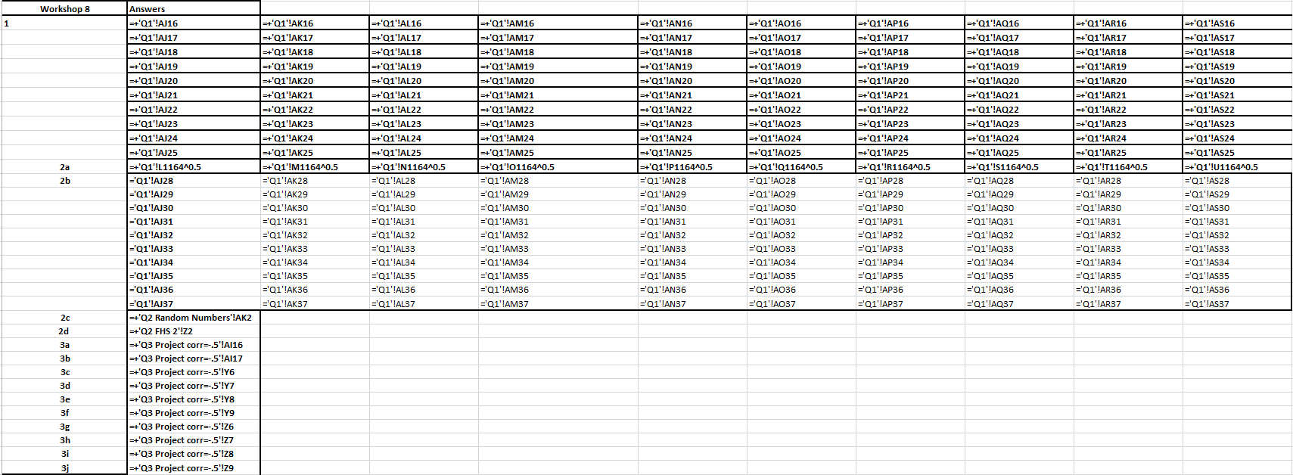

Question 1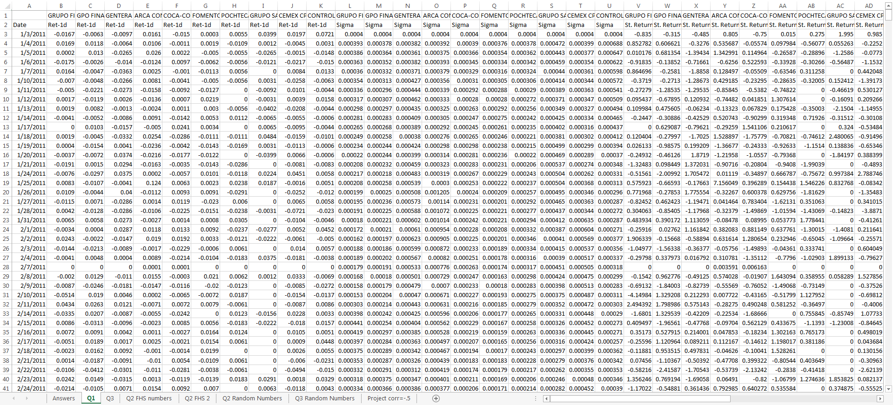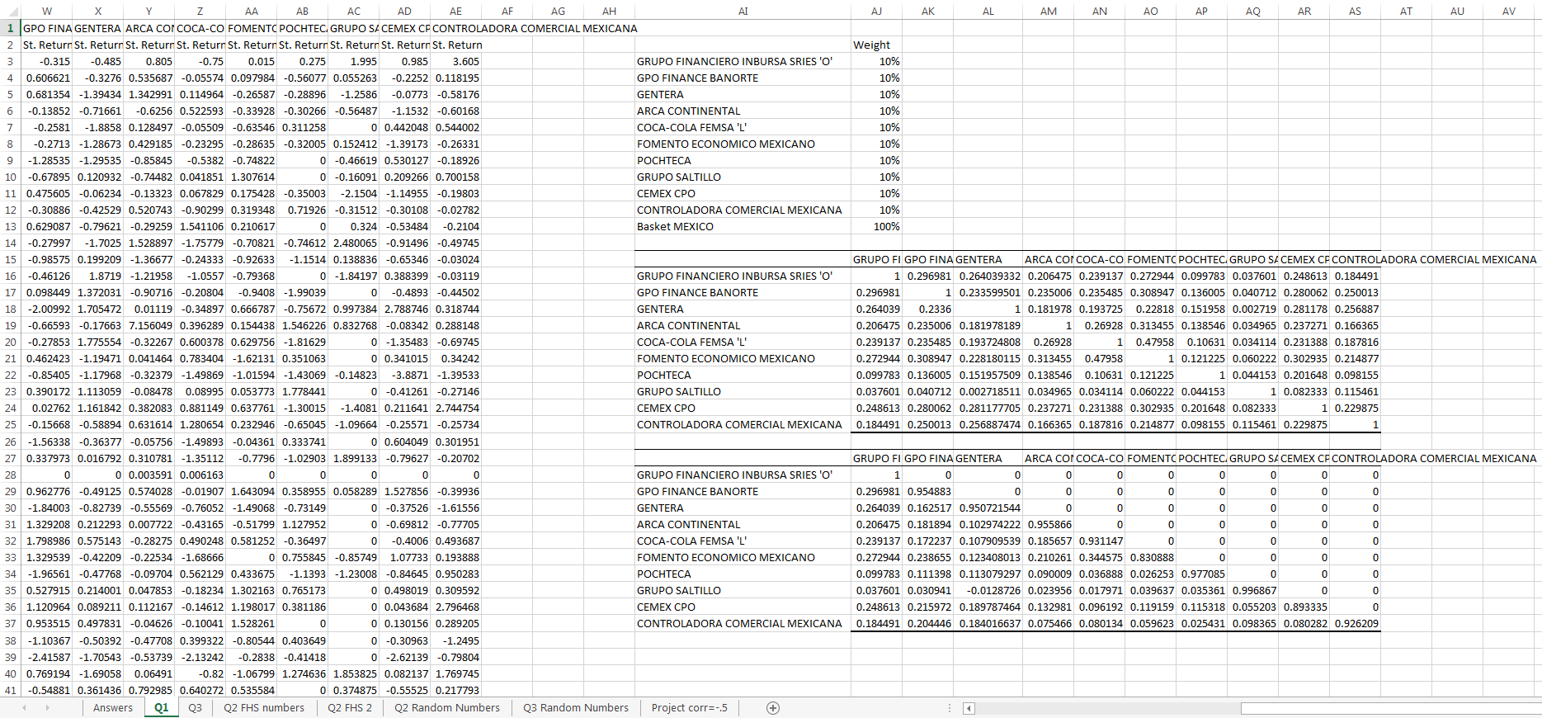

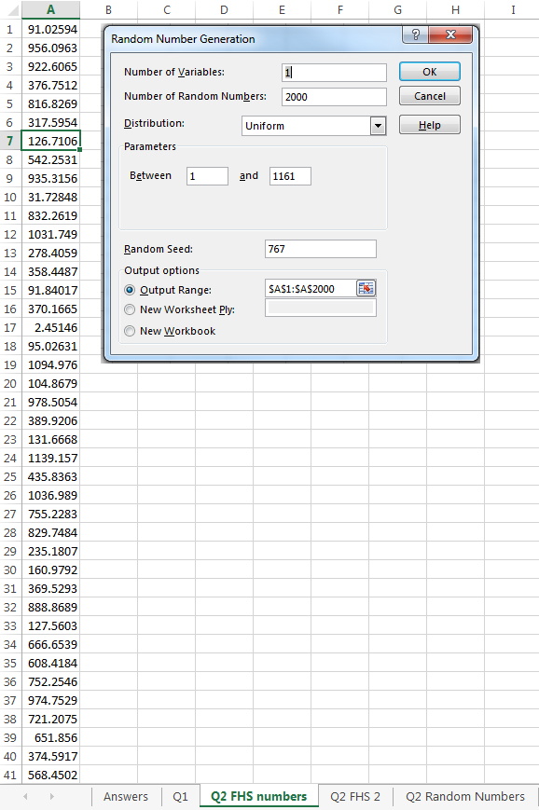Question 2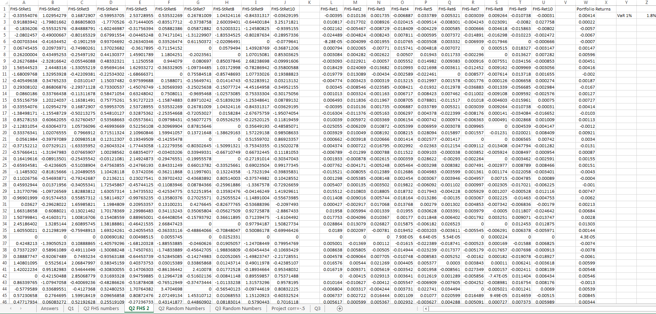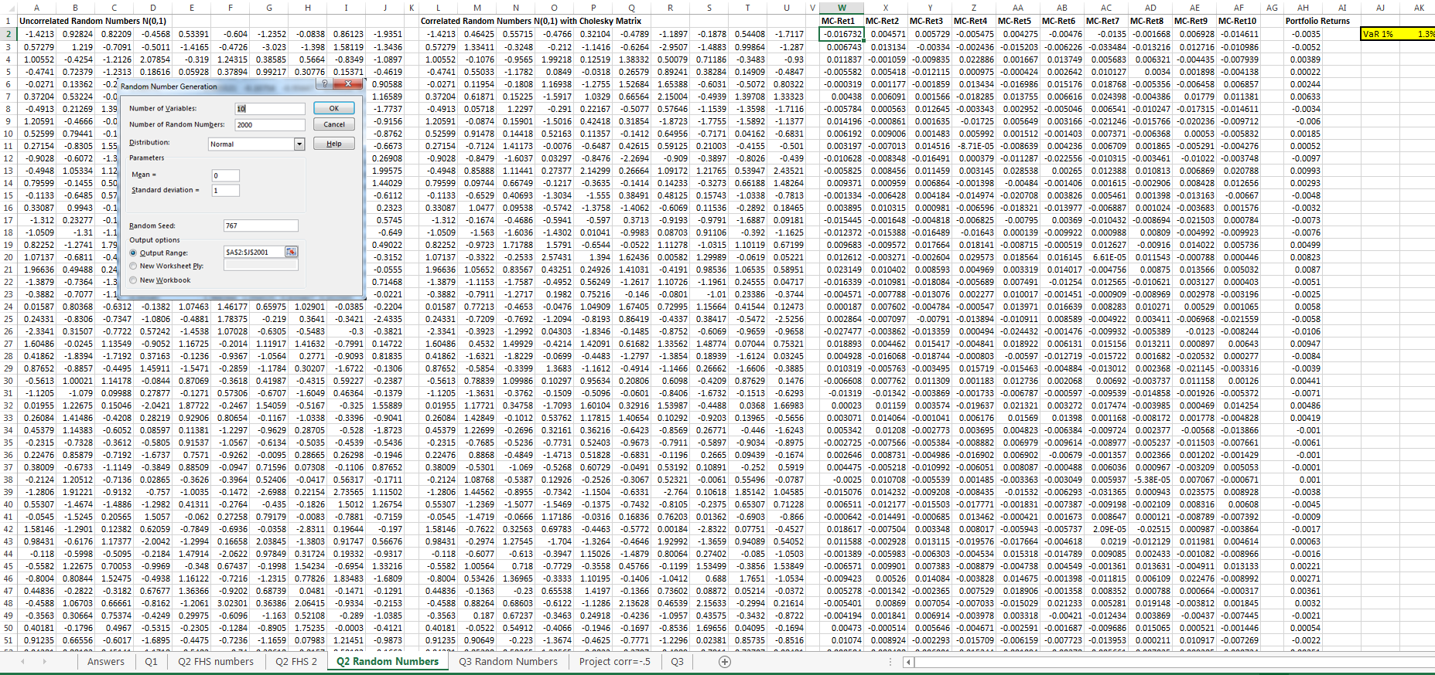

Question 3

